**Li Xingxuan 1002189**

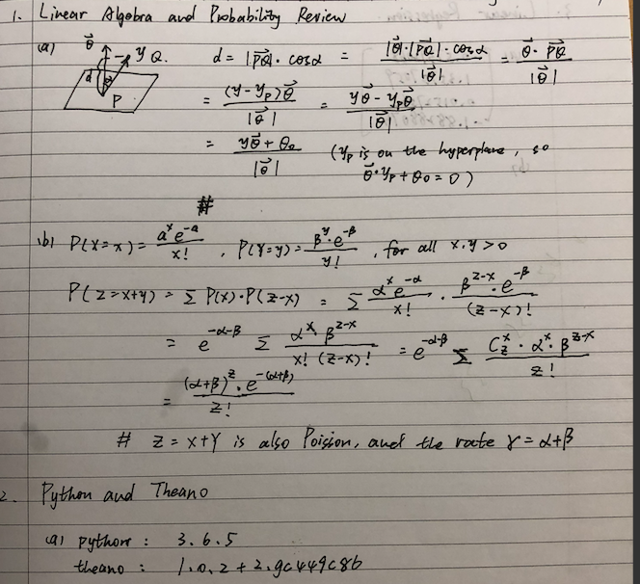

**(a) Original Code Result:**



**(b) Eexact solution:**

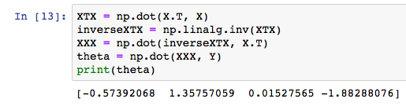

**(c) Sklearn:**

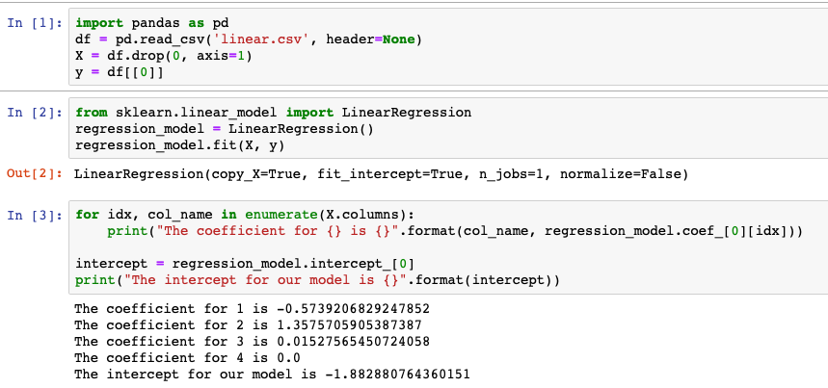

**(d) SGD**

%**matplotlib** inline

**import** **numpy** **as** **np**

**import** **matplotlib.pyplot** **as** **plt**

**import** **random**

data = np.genfromtxt('linear.csv',delimiter=',')

X = data[:,1:]

Y = data[:,0]

*# print(type(X))*

In [42]:

**def** mini_batch(X, y):

loc = random.randint(1, 44)

result_X = X[loc:loc + 5, :]

result_Y = Y[loc:loc + 5]

**return** result_X, result_Y

test_X, test_y = mini_batch(X, Y)

*# print(test_X, test_y)*

In [20]:

**import** **theano**

**import** **theano.tensor** **as** **T**

x = T.matrix(name='x') *# feature matrix*

y = T.vector(name='y') *# responese vector*

w = theano.shared(np.zeros((4,1)),name='w') *# model parameteres*

risk = T.sum((T.dot(x,w).T - y)**2)/10 *# empirical risk*

grad_risk = T.grad(risk, wrt=w) *# gradient of the risk*

In [41]:

n_steps = 1000

lost_list = []

w_dict = {}

**for** i **in** range(n_steps):

for_x, for_y = mini_batch(X, Y)

train_model = theano.function(inputs=[],

outputs=risk,

updates=[(w, w-(1/(i+1))*grad_risk)],

givens={x:for_x, y:for_y})

*# print(train_model())*

*# print(w.get_value())*

lost_list.append(train_model().item(0))

w_dict[lost_list[-1]] = w.get_value()

print(w.get_value())

print(lost_list[-1])

lost_list.sort()

print(w_dict[lost_list[0]])

print(lost_list[0])

[[-0.57992765]

[ 1.35436854]

[ 0.01884709]

[-1.88086824]]

0.006610305112215585

[[-0.5673264 ]

[ 1.34984663]

[ 0.017143 ]

[-1.87757628]]

0.0007559927287628303